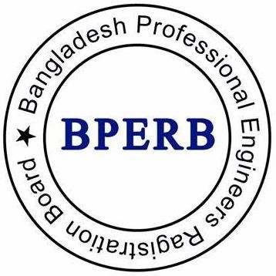
Bangladesh Professional Engineers Registration Board

Sponsor’s Report

Sponsor’s Name: PEng/IEB Membership No:
Candidates Name: IEB Membership No:

April, 2025

SPONSOR’S STATEMENT

Sponsor Requirement
All applicants must be supported by at least two sponsors for professional review submission. Sponsor must understand the requirements of the professional review process and the competence for being the professional engineer. All members must be professionally qualified and registered as PEng with a minimum of three years of registration tenure or IEB Fellows with a minimum of ten years of status.

Instructions for the Sponsor
This form is to be submitted to support a candidate applying to become a Professional Engineer. The statement of support is an important part of the candidate’s application. Please take the responsibility seriously and provide an effective statement to support. You must know the candidate professionally, understand the required competences of the applicant, and how they have met them. At the end, the sponsor is to declare on the statement that

“The candidate is a competent and appropriate person for being a professional engineer.”

If you feel that the candidate is not competent or not in a position to become a Professional Engineer, you may decline the application. Sponsor must complete all sections of this form and provide a statement of support of no more than 600 words describing, from personal knowledge, that the candidate possesses the requisite abilities and characteristics. The sponsor must review and scrutinize the candidate’s submission and be happy that it demonstrates all the competences as required by the BPERB. It is expected that you will provide advice during their preparation will be reflect on their presentation and practice interviews.

Returning the Sponsor’s Report
You must complete the statement of support based upon your personal knowledge of the candidate. Under no circumstances should the candidate complete this form. You must take all reasonable measures to guarantee that the statements you have made are accurate, comprehensive, and not misleading. If this is not done, the IEB's professional code of conduct may be violated, and you, as an IEB member, may be subjected to disciplinary proceedings.
The completed sponsor report must be submitted though the online portal by uploading as soon as they received it (usually within two weeks of application). Alternatively, the sponsor may send the hardcopy in closed/concealed envelope to BPERB office. If you experience any issue with the online portal, please send email to bperb.ieb@gmail.com.

Please complete all sections below before uploading the form.

- CANDIDATE’S INFORMATION

Candidates Full Name
IEB Membership No

- SPONSOR’S PARTICULARS

Sponsor’s Full Name
PEng Registration No
IEB Membership No
Please state a professional institution if you are a non-IEB member
Do you have full knowledge of the current review requirements? Yes / No
How long have you known the candidate |  | Years Months
Are you still in regular contact? |  | Yes / No
In what capacity are you associated with the candidate?
Address
Email Address
Phone Number

- SPONSOR’S STATEMENTS
Please provide a statement of no more than 600 words (not less than 200 words) describing from your personal knowledge that the candidate possesses the requisite level of knowledge, skill, experience and characteristics for being the Professional Engineer. (The box is expandable. You may add separate sheet in case of hard copy and combine it to a single pdf)

- SPONSOR’S DECLARATION

I Engr. recommend the admission of the candidate from personal knowledge and am fully convinced that the candidate possesses the requisite abilities and characteristics for the grade he is applying. I believe that the candidate is a competent and appropriate person for being a professional engineer.

Signature* Date

(* in case the sponsor doesn’t have a digital signature, just write “name”.)

